Marlene Bagnull
Get | Your
Book in Print!
How Can I Know God  Has Called Me to Write a Book?  Laying a Solid  Foundation  Book Proposals that Work | 6.5 HOUR Seminar on CD  Marlene  Bagnull Litt.D.

GET YOUR BOOK IN PRINT ~ SEMINAR
God has given Marlene the joy and privilege of being part of Christian publishing since 1968. She has made over 1,000 sales to Christian periodicals, authored five books, and compiled and edited three other books.
In 1983 Marlene founded the Greater Philadelphia Christian Writers Fellowship and directs their yearly conference. Since 1997 she also has directed the Colorado Christian Writers Conference.
Marlene’s ministry to the Christian writing community extends further through editing and mentoring services, writing seminars and retreats, a women’s critique group, At-Home Writing Workshops, and her independent publishing company Ampelos Press.
Marlene is anointed to share her writing and publishing wisdom with others. She cares about her students and her teaching is fresh and current. She is making a difference.
Linda Evans Shepherd ~ Longmont, Colorado

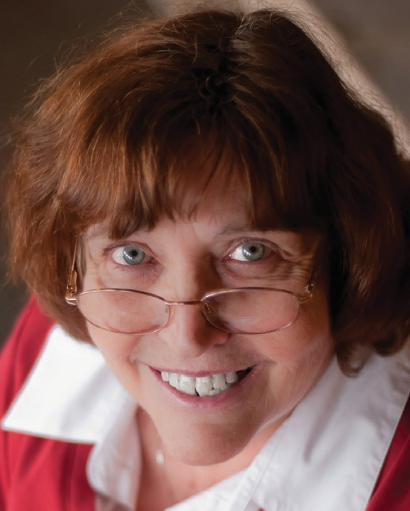

.

951 Anders Road, Lansdale, PA 19446 mbagnull@aol.com Phone: 484-991-8581 www.writehisanswer.com

Hooking Your Readers from the Get-Go

Independent
Publishing

Spreading the Word through Effective Promotion

