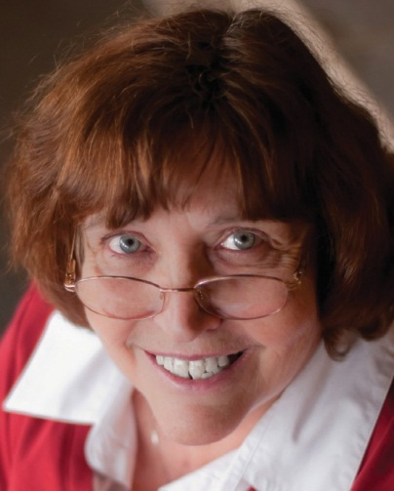

**Marlene Bagnull  
 Litt.D.**

*Part Bible Study, Part Testimony,*

*& Part How-to.*

951 Anders Road,

Lansdale, PA 19446 [mbagnull@aol.com](mailto:mbagnull@aol.com) Phone: 484-991-8581 [www.writehisanswer.com](http://www.writehisanswer.com/)

I felt a call to full-time Christian service as a teenager. If anyone had told me then, however, that God was calling me to a writing and speaking ministry, I would have said, “A loving God would *never* do that to me!” I hated English in high school, and I was terrified of the public speaking class we were required to take.

God’s plan was certainly not my plan. Instead, it is “infinitely beyond [my] highest prayers, desires, thoughts, or hopes” (Eph. 3:20 tlb)! He has given me the joy and privilege of being part of Christian publishing since 1968. I have made over 1,000 sales to Christian periodicals, authored five books, compiled and edited three books, and received an honorary doctorate for my work with writers.

It is my great desire to encourage and equip you to write about a God who is real, who is reachable, and who changes lives.

*I thank God every day for the gifts He has given Marlene. Her ability to inspire is unparalleled.* J.L. Hardesty ~ Steamboat Springs, CO

**Bagnull**

**Marlene**

**GOING & GROWING ~ WRITING & SPEAKING**

*oing & Growing*

WRITING

&

SPEAKING

*. . . through the Hurts*

*Jesus never promised it would be easy to follow Him,*

*but He has promised always to be with us.*

*G*