Marlene Bagnull
WRITE HIS ANSWER ~ SEMINAR
God has given Marlene the joy and privilege of being part of Christian publishing since 1968. She has made over 1,000 sales to Christian periodicals, authored five books, and compiled and edited three other books.
In 1983 Marlene founded the Greater Philadelphia Christian Writers Fellowship and directs their yearly conference. Since 1997 she also has directed the Colorado Christian Writers Conference.
Marlene’s ministry to the Christian writing community extends further through editing and mentoring services, writing seminars and retreats, a women’s critique group, At-Home Writing Workshops, and her independent publishing company Ampelos Press.
Thank you for the enthusiasm and expertise in writing you so passionately shared. Your “Write His Answer” Seminar will be the standard by which I will judge all future seminars.
Robert L. Kornegay, North Carolina

W

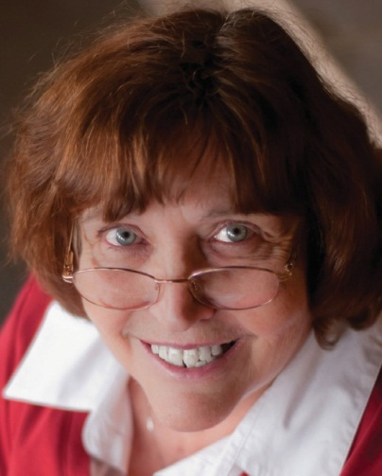

Idea to Published
Manuscript

Writing Manuscripts that Sell and

rite
HIS Answer
Bible Studies  Called to Write? Write His Answer  Writing from  Personal Experience  Getting Started | 7.5 hour seminar  Marlene  Bagnull Litt.D.

951 Anders Road,
Lansdale, PA 19446 mbagnull@aol.com Phone: 484-991-8581 www.writehisanswer.com
Touch Lives

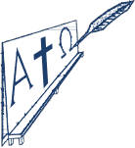
Making It
Happen

